**POINTERS!**

num1 = 11

num2 = num1 (What’s happen here?)

Both point to the same storage in memory

And now?  
num2 = 22  
  
num2 will be 22, and num1 will be 11

Integers are immutable. Therefore, they can’t change.

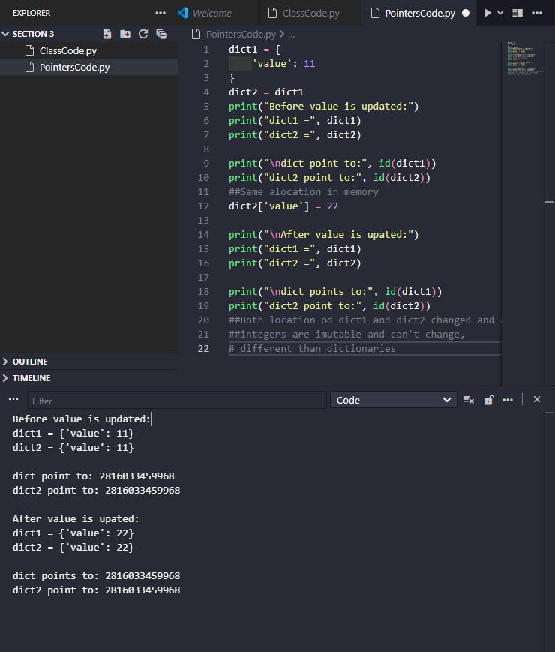

Dictionaries can change!

